DIRECTView Visualization Tool

Simulation Results Visualization

Booz Allen Hamilton

Southern Methodist University

Table of Contents

Introduction 3

DIRECTView 4

Graphical User Interface (GUI) 4

Measure of Effectiveness (MOE) 4

Geography 4

Scenarios Filters 5

# Introduction

DIRECTView consist of the source-code for a visualization module developed as part of the DIRECT simulation software package by the AMS (Analysis, Modeling and Simulation Testbeds for DMA and ATDM Evaluation) Dallas Testbed and enables users to visualize the simulation-based measures of effectiveness as a function of different simulation scenarios. The application reads data from XML based simulation output and is coded in C-sharp. The codebase for DIRECTView is developed by Southern Methodist University.

# DIRECTView

The DIRECTView application is an executable file recognized as a .exe extension. The application is used to convert simulation result outputs from the DIRECT traffic simulation software into graphical representation. The application is able to import multiple datasets from various analyzed operational conditions to compare against the baseline condition.

## Graphical User Interface (GUI)

The following Figure 1 shows an example of the DIRECTView application.

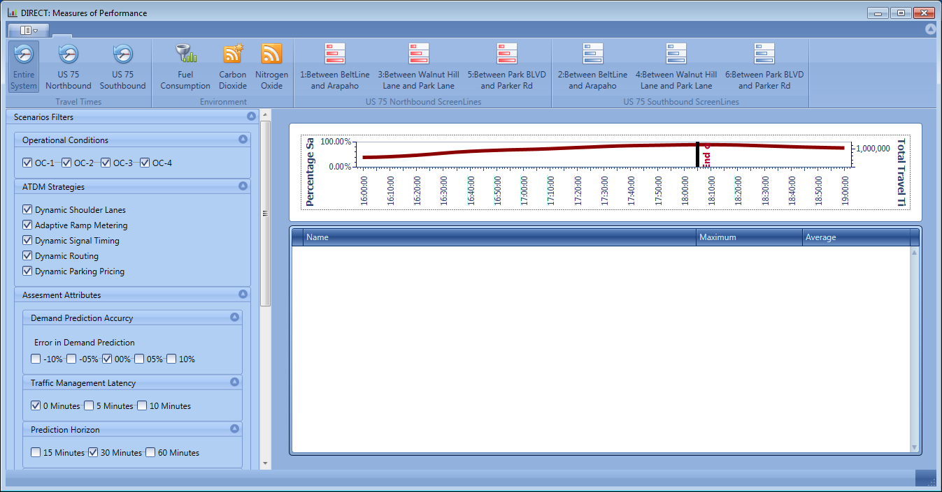

Figure 1: Sample DIRECTView Graphical User Interface

## Measure of Performance (MOP)

The DIRECTView GUI is able to plot a comparison of various MOP versus time from 4:00PM to 7:00PM as listed below:

1. Travel Times (Minutes and Percent Change)
2. Environmental (Fuel Consumption, Carbon Dioxide (CO2) emission, and Nitrogen Oxide (NO) emission)

These variables are also shown in Figure 1 above on the ribbon located at the top left section of the ribbon. The plotted line graph dynamically changes by clicking each various MOP or travel time direction to reflect the results of interest.

## Geography

Located within the top right of the ribbon shown in the DIRECTView from Figure 1 are the buttons for the geography of interest within the Dallas, Texas testbed. Users are able to limit the results within a one of the six geographical location of interest to analyze. The geographical locations are divided into US 75 northbound or southbound and into the following boundaries:

1. Between Beltline and Arapaho
2. Between Walnut Hill Lane and Park Lane
3. Between Park Boulevard and Parker Road

## Scenarios Filters

The scenarios filters are located on the left and contain the following sub-filters:

1. Operational Conditions
2. Active Transportation and Demand Management (ATDM) Strategies
3. Assessment Attributes

These scenario filters use check boxes where various combinations from each sub-filters can be selected for comparison when analyzing the results. The assessment attributes filter is further classified into the following sub-filters:

1. Demand Prediction Accuracy
2. Traffic Management Latency
3. Prediction Horizon
4. Coverage Extension

# File Structure

The following Figure 2 shows the DIRECTView folder structure of organizing the application launcher, GUI display variable files, and simulation result files. The DIRECTView application executable file shall be located within the *Main Folder* along with the DIRECTView.vshost.exe and 24 DevExpress.dll files. Within the *Main Folder*, a folder should be designated as *Input* and contain the directory information for the simulation input files.

The Data.txt file lists all the folders scenario names located within the *Operation Conditions and Scenarios Folder*.

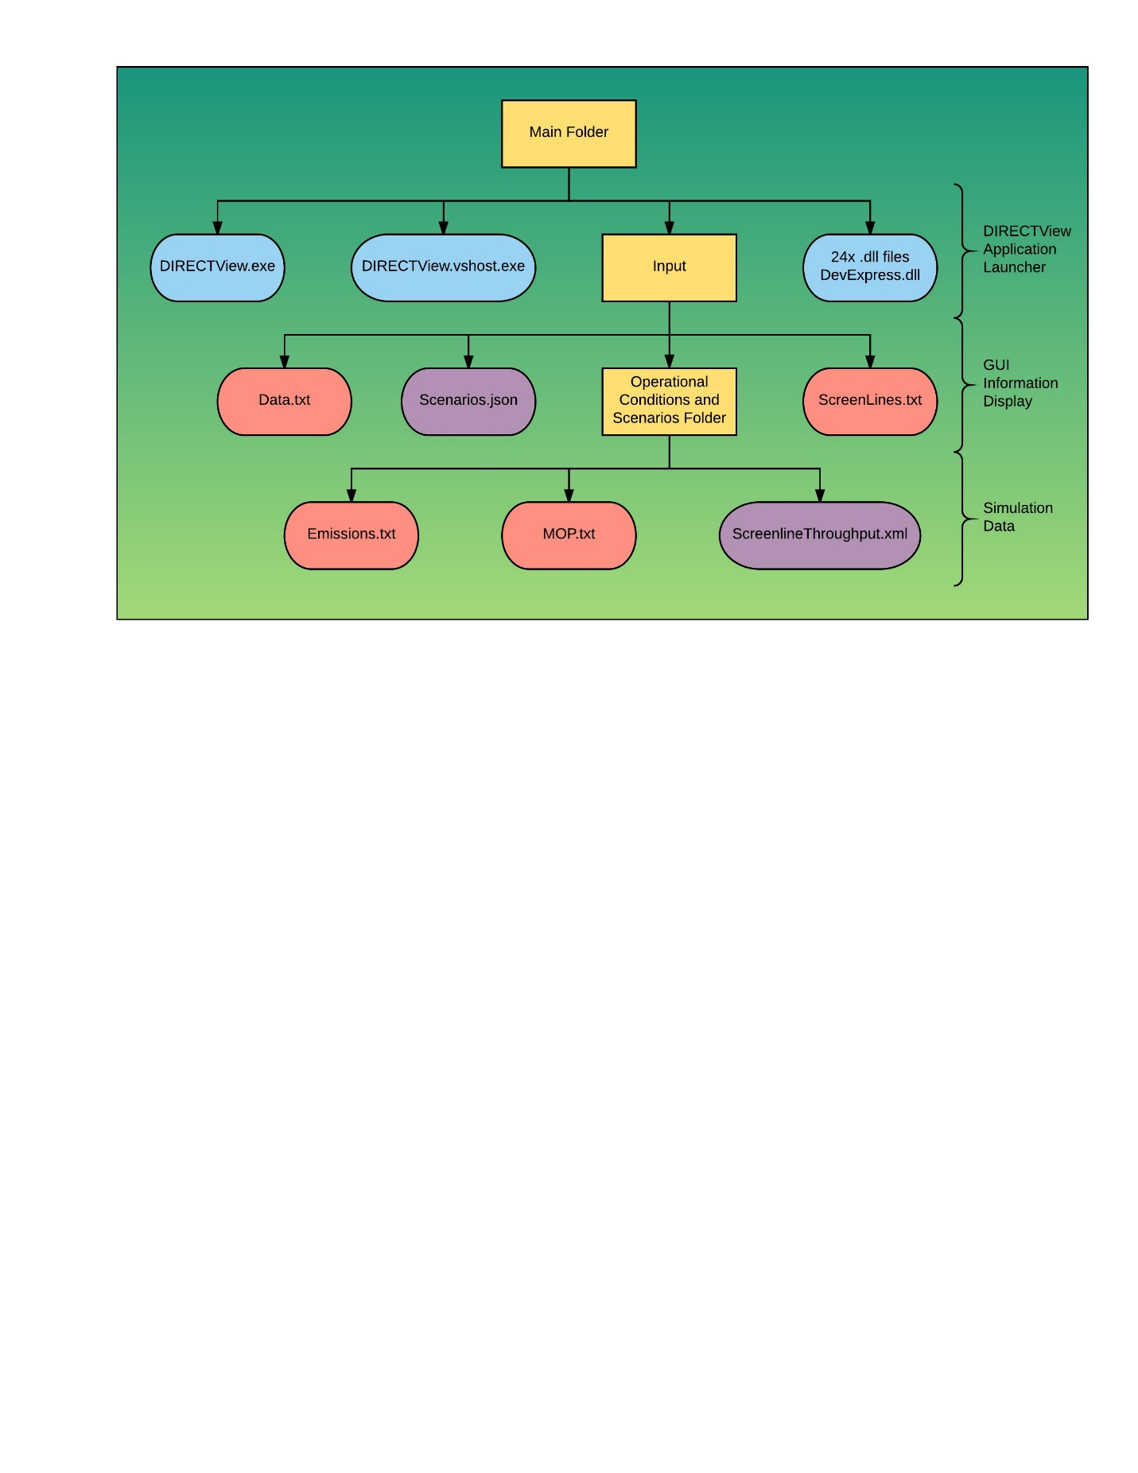

Figure 2: DIRECTView Folder Structure